Brussels Hotels list 2017

Please find below a list of hotels close to the COST Association. We have negotiated corporate rates based on “the first come, first served”. That means that if there is no more standard room available, the hotel will give you a bigger room for a more expensive price. Please note also that the prices may change during the congress periods (see the dates at the bottom of the page).

Could I kindly ask you to always make a reservation either by sending an email to the hotel or through the
website with our client ID or login number? Please always mention “COST Association” when you reserve a room.
Please note that the special COST corporate rates are only available if booked directly with the hotel and not through external internet booking systems such as www.booking.com.

Please note that the COST Association does not book hotel accommodation for delegates. Delegates are required to make their own hotel bookings and only contact bookings@cost.eu in case of a
problem.

■ NH Brussels City Centre****
17, Chaussée de Charleroi
1060 Brussels | Prices :
Tel : +32 2 539 01 60 (general) | Single room:
+32 70 359 968 (reservations from BE) | week rate 114€/night, breakfast inc  weekend rate 75€/night, breakfast excl. (15€) city tax excl. (6€)  COST rates only available via email with our
Fax: +32 70 35 99 69 | client ID number 2003682685
Email: vip.reservations@nh-hotels.com
Website: http://www.nh-hotels.com

A 246 hotel rooms and 9 suites with fax-modem connection, television, telephone, air conditioning, minibar, room-service, dry cleaning service. Free access to Internet in the public area of the hotel (lobby, breakfast and brasserie) and Internet connection FREE in the room. Free access to the fitness area. Bar Brasserie, parking. Traditional restaurant-bar.

■ Four Points Hotel Sheraton****
15, Rue Paul Spaak | Prices:
1000 Brussels | Single room:
Tel: +32 2 645 61 11 (general) | week rate 120€/night, breakfast incl.
 | weekend rate 89€/night, breakfast incl.
Fax: +32 2 646 63 44 | COST rates only available via email with our
Email: fourpointsbrussels@reservestarwood.com | rate code SET number 334439
Website: http://www.fourpoints.com/brussels

A 128 hotel rooms with flat television, telephone (direct dial), air conditioning and mini-bar. FREE access to the high speed internet connection in the room and free access to Internet in the reception area. Free access to the fitness-sauna area. La Four'chette Restaurant.

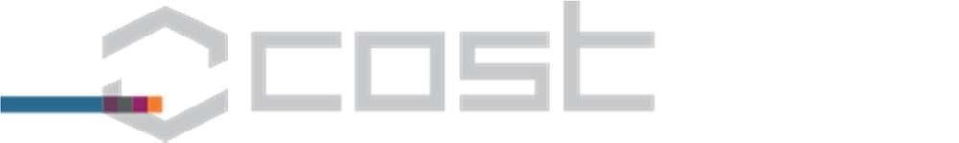

  
  

■ Pentahotel Brussels City Centre****
38, Chaussée de Charleroi Prices:
1050 Brussels Single room:
Tel: +32 2 533 66 66 (general) week rate 120€/night, breakfast incl.
+32 2 533 67 63 (reservations) weekend rate 120€/night, breakfast incl. Fax: +32 2 538 90 14
COST rates only available via email
Email: reservations.brussels.center@pentahotels.com
Online booking: https://gc.synxis.com/rez.aspx?Hotel=60842&Chain=15318&locale=en-
US&promo=COST2016
Website: http://www.pentahotels.com

A freshly renovated 201 hotel rooms with television, telephone (direct dial), FREE WIFI in the room, Internet corner, air conditioning, mini-bar, dry cleaning service, cosy bar, parking, and a free access to the fitness center.

■ Hotel Bristol Stephanie - Thon Hotels****
91-93, Avenue Louise | Prices:
1050 Brussels | Single room:
Tel: +32 543 33 11 (general) | week rate 120€/night, breakfast incl.
+ 32 2 543 33 70 (reservations) | weekend rate 80€/night, breakfast incl.
Fax: +32 2 538 03 07 | COST rates only available via email or
Email: reservations@bristol.be | on their website with login TH21586122
Website: http://www.thonhotels.be/bristolstephanie

A luxurious 4* hotel with 142 hotel rooms with television, air conditioning, mini bar and telephone. FREE WIFI in the rooms. Free access to the fitness and sauna area.
10 % on the food and beverage at The « Stefany's » Bar and the gastronomic restaurant “Ninty one”.

 Congresses and events 2017
Special COST Association rates are not applicable
20-03-2017 - 23-03-2017 (Intensive Care)
24-04-2016 – 26-04-2016 (Seafood Exhibition)
25-09-2017 -28-09-2017 (Label Expo) 09-10-2017 – 12-10-2017 (Open Days)

